System Design

1)**Design Approach:** This project is based on the functional design approach, which helps us to design the project in project in a simpler way by using its flow, use cases, sequence diagram, Entity relationship etc. For example, there are different modules in this project which have separate functionality and, other sub functionalities. All the modules are designed, implemented and integrated together to make a flawless working application.

2)**Detailed Design:** The detailed design including modules and sub modules of the application is as follows.

i)**User Registration:** If the user wants to use the Bashabari application, they must install the application from play store. They have to register through register page. Registered information is stored on the firebase real-time database. After register, homeowner can login and can use our all feature of the application.

**Owner System Design:**

1)Owner home page: There is a request section where recent request from tenants will appears. There is an also see more notice option where owner can see all request from tenants. In the home page, Owner name and home address also appear. To see request, we need to design and implement several java and xml file like Request java and xml, Request Adapter, Request Info and Request card view.

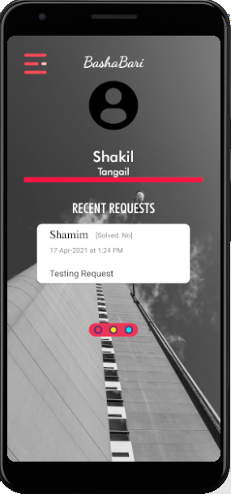 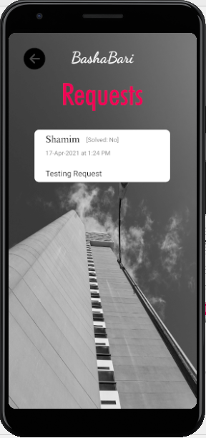

2)Owner profile: In owner menu there is a Profile section. In profile section owner can see his details like name, phone number, national id number and password. This information we will get from Owner Database and owner also can update his information as well as he can change his password.

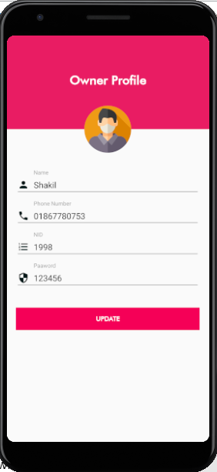

3)Notice Section: In owner menu there is Notice section. In this section, Owner can send notice to tenants. And recent notice also appears in this section. Top of the layout we use edit text to write the notice and there is send option. After sending this information will store in Database. And Below send notice option, we use recycler view to show the recent notice of the owner.

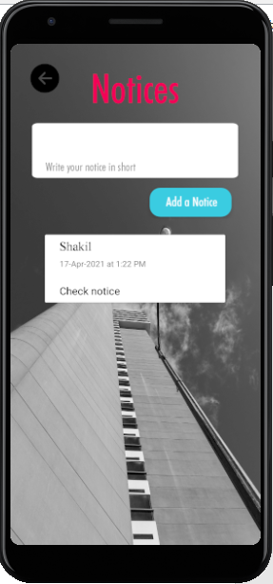

4)Message section: There also a message section in owner menu. In this section, all tenants under owner will appear. If owner want to send any personal message rather than a notice. Owner can message any tenants. He can scroll the recycler list to find the tenants or there is search option in the top from where he can search for tenants. If he selects any tenant to send message, a new message section will appear from where he can send message.

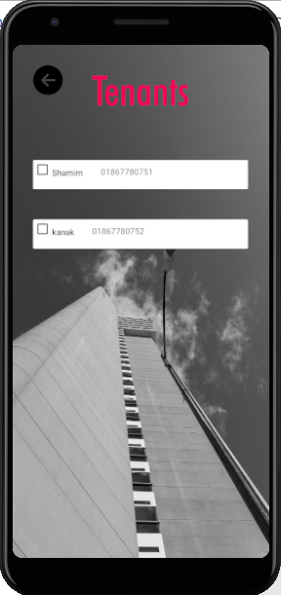 s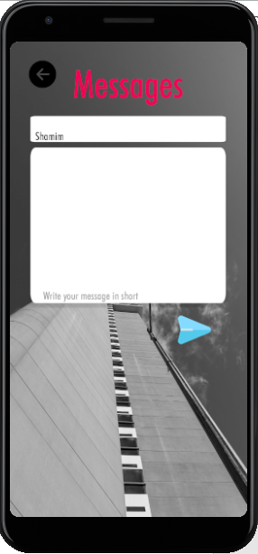

5)Register Tenants: In the register tenant section, owner can add tenants. Owner has to provide tenants information like Name, Flat no, Nid no, Phone Number, password etc. This data will store in real-time database. After this registration, tenants can login in this system. For, tenants there is a different Home page, menu option etc.

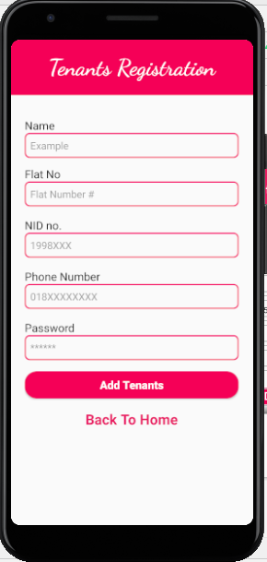

6)Bill section: There will a bill section in owner menu from where owner can send bill information to tenants monthly.